Aveiro, 03 October 2014

Subject │ Minutes of the Third Management Committee Meeting of COST Action IC1301 “Wireless Power Transmission for Sustainable Electronics (WiPE)”

Toulouse, France
30 September 2014

- Welcome to participants

A welcome speech was given by the Action Chair to welcome the MC’s to the meeting, we had 27 participants including MC chair and substitutes.

- Adoption of agenda

The agenda for the third meeting was presented and the MC’s were asked to propose new items to be discussed. No new items were considered.

- Approval of minutes and matters arising of last meeting

The minutes from the last meeting were already voted by e-mail and were just confirmed here.

- Update from the Action Chair

The status of Action, including participating countries, were presented to the MC Members and the actual status is:

Number of signatories: 26
Number of non-COST members: 1
Number of COST country entities (institutes, etc.) currently participating: 50
Number of non-COST entities (institutes, etc.) currently participating: 0

Number of MC Members: 45

A new preliminary budget was presented to the MC’s, and the decision to vote this new budget was decided to be finalized via e-mail, but the voting process will be pending from a communication to the COST office about new rules for next year.

The STSM status was also presented, based on the information from Prof. Zbynek Raida who is our STSM committee chair.

The STSM previewed grants were used in this year as expected, with the following list of grantees:

Schutz - CTTC - Spain
Gonçalves - Georgia Tech - USA
Mariotti - Instituto de Telecomunicações - Portugal
Kalialakis - CTTC - Spain
Loss - Ghent University - Belgium
Brás - HIT-Holon Institute of Technology - Israel
Lopez - Ghent University - Belgium

The budget for this year regarding STSMs was completely used, but the MC’s proposed that if there is any additional budget from other activities available, the COST office should be contacted for new STSMs.

The committee was informed that a bi-monthly newsletter has been created and inputs were requested.

- Promotion of gender balance and of Early Stage Researchers (ESR)

As was seen in the STSM actions, 3/7 (43%) of the grants were attributed to female researchers. Moreover, Gender balance is being discussed by implementing a women prize, Prof. Alessandra Costanzo is the responsible person for initiating this activity.

- Follow-up of MoU objectives

An update from the working groups was given, the Action chair proposes that each working group chair starts the creation of a position/white paper in the sense that at the end of each year the COST members have an idea of the main driving research and industrial areas in each of the working groups. This activity was already started by some WG’s, but more activity from others is needed. The main objective was summarized with the next diagram:

Position Papers

The actual status of the WG’s is:
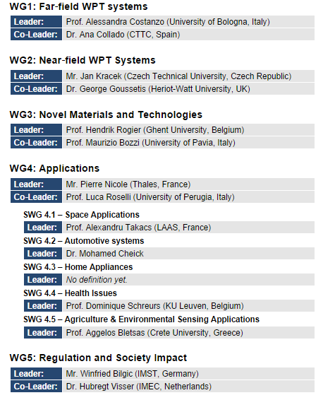

Another activity that was proposed to the action members was to “share simple circuits” on the internet and create a database of circuit design for WPT, this was postponed for a future discussion via e-mail.

Finally the MC’s members were asked to fill out a form of who’s who in WPT in Europe, the first available information is already available online at:

http://www.cost-ic1301.org/?page=partners

- Update from the Grant Holder

The grant holder present a current status of the COST IC1301 action budget.

- Location and date of next meeting

Several institutions were proposing to host next events, those include for the combined workshop and MC meeting 4 and 5, the next locations (by order of proposal):

Proposal 1

Thessaloniki - Greece
John N. Sahalos & Antonis Dimitriou
University of Nicosia, CYPRUS & Aristotle University of Thessaloniki, GREECE,

Proposal 2

Grenoble Institute of Technology
Prof. Smail TEDJINI,

Proposal 3

Institute of Microwave and Photonic Engineering
Graz University of Technology
Jasmin Grosinger, RFID Technologies Group

The three proposals were voted with the following outcome:

Place | MCM4 (March-April 2015) | MCM5 (September-October 2015) | Abstain
Proposal 1 | 2 | 20 | 5
Proposal 2 | 0 | 2 | 25
Proposal 3 | 20 | 0 | 7

- Summary of MC decisions

The Action Chair made a final summary of the meeting.

- Closing

The meeting was closed around 16:30

